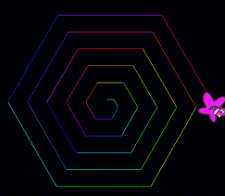
Task 7 Geometric Patterns

You will create a sprite that makes various geometric patterns.

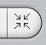
- Create a stage that is all black

- Insert a sprite of your choice. Make it quite small using the shrink sprite tool

- Create a variable called "Steps"

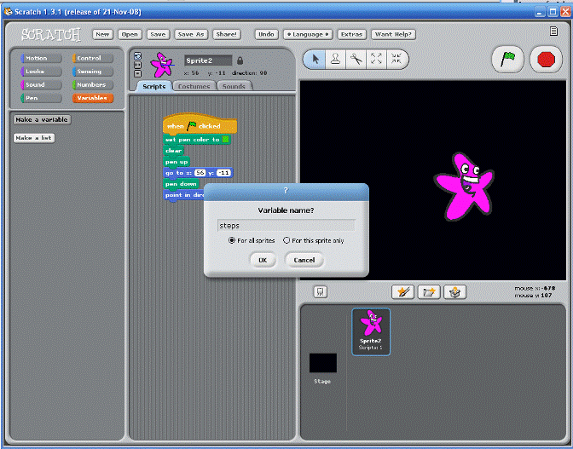

- Write this script for your sprite
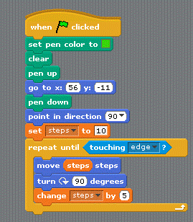
- Let’s make it more colourful by adding

- Change the turn block from 90 degrees to 45 degrees. Run the Script

- Change the turn block from 45 degrees to 30 degrees. Run the Script

- Change the turn block from 30 degrees to 60 degrees. Run the Script

- Change the turn block from 60 degrees to 70 degrees. Run the Script

- Change the turn block from 70 degrees to 80 degrees. Run the Script

- Into the last script lets add a forever loop so it looks like this:
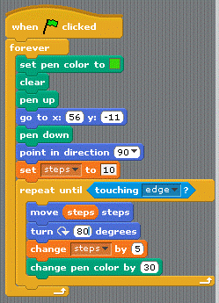

- Create a new variable called "degrees"

- Change things a bit by changing degrees to 90 and inserting the degrees variable into the turn block so it looks like this:

- And finally let’s be random replace degrees with a random number between 1 and 360 and include in the forever loop.

- Save your work as "Pattern" in your N:-Scratch folder.

